The Ewood revival

I decided to start a new game of CM00/01 to bring back the glory days to my favourite club Blackburn Rovers.
With 20 million pounds in the bank I had a lot of resources to spend and here’s what I made of it:

TRANSFERS IN

Aki Rihiniemi 100.000 youth player; no first- team chance yet
Ian Ross 250.000 one of my most important
first-team-players
Carlos G. Correa free transfer one of my most important
first-team-players
Enrique Estebaranz 75.000 very old but also very good
striker (used in a rotation sys.)
Gary Holt 500.000 very important first-teamer and
a real bargain
Dejan Markovic 300.000 striker who just played a handful
games
Robert Lee 1.000.000 midfield fighter who is old but
was one of my best players
Hugh Murray 1.000.000 very good youth player but no
first-team-chance yet
Iain Durrant 400.000 a solid backup for my first-team and may have a future as coach
Mark Tobin free transfer 14-year-old supertalent to learn
in the reserves
Michael Standing 675.000 another great talent with no first-
team-appearance yet
Matt Jackson 300.000 a solid backup for my defence
with only a handful matches
Nikos Iordanidis 1.800.000 my biggest talent – sure to be
worldclass in 3 years
Marc Bircham 1.500.000 rotation player in def. midfield
who averaged 20+ matches
Graham Lancashire 20.000 backup striker with just 5 games
In the whole season
Grant Brebner 1.000.000 youngster to learn in the reserve team
Edwin Vurens 150.000 backup striker who never really
showed his great ratings
Steven McGarry 1.000.000 another one for the youth team
with no 1st team-match yet
Darren Beasley 500.000 vital first-teamer in my central
defence
Sean Hessey 2.500.000 solid backup for my defence and
still very young
Ross Tokely 100.000 another prospect that plays in
the reserves so far
Frederic Kanoute 5.000.000 brilliant striker at a young age
who should make it to the top
Jason Gavin 350.000 young defender who seems to
be quite a good pick

TRANSFERS OUT

Brad Friedel 500.000 not needed by my club at all and
never figured in my plans
Stig I. Björnebye 500.000 good player but not needed in
my style of play
Simon Grayson 500.000 very average allrounder who just
hadn’t the class to play for Rov.
Jeff Kenna 1.000.000 championship hero from 1995
but not needed anymore
Matt Jansen 8.250.000 youngster who I never really
wanted to sell – but a good deal

With total confidence in my side I started the season. Everything else than position one would have been a disappointment but my team produced one fine performance after another and after 46 matches I had broken all records.

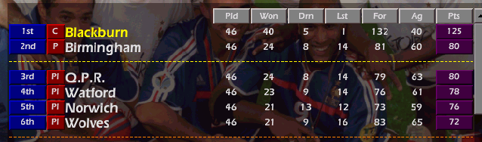
My starting lineup was the following:

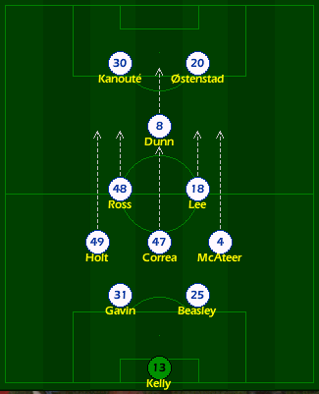

nr. Name av.rat. goals
13 Alan Kelly 7.29 GOALKEEPER
31 Jason Gavin 7.09 2 goals
25 Darren Beasley 7.19 3 goals
49 Gary Holt 7.93 9 goals
47 Carlos G. Correa 7.91 11 goals
4 Jason McAteer 8.10 12 goals
48 Ian Ross 7.84 17 goals
18 Robert Lee 7.81 5 goals
8 David Dunn 8.02 27 goals
30 Frederic Kanouté 8.29 12 goals
20 Egil Ostenstad 7.85 16 goals

Not too bad, right ???

Now the Premiership is on my way and my aim is definitely clear: I want to bring Blackburn into the Champions League at the first attempt although I’ve just been promoted. I’m sure it will happen. I hope … ☺

SEASON 2

You may now think that I’m a stupid arrogant idiot because I said my aim is to lead my promoted team to the Champions League in my first season. Let me assure you I wouldn’t say something like that without reasons.
Well, don’t let me do some stupid talking, this is how the season finished:

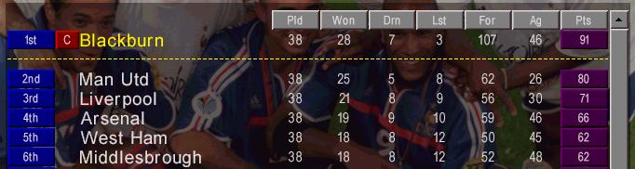

Champion at the first attempt ! YES !!!

I also reached the final of the FA Cup but unfortunately …

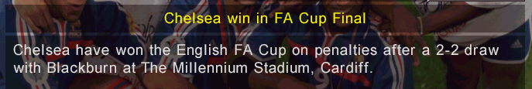

However my first season was one to remember. Now I’ve got my eyes
set on making Blackburn the record winner of the Premiership. Just
about 20 championships to go ….

